**COVID 19 Update**

May 12, 2020



On Friday, March 27, 2020, the President signed into law the CARES Act, which contains funding for American workers and nonprofits like the CSF.

The CARES Act established the temporary Payroll Protection Program (PPP) to address the COVID-19 outbreak and provide loan forgiveness for retaining employees.

Regions Bank, a partner with CSF since the 1960’s, supported the Foundation in the application process; on May 4, 2020, CSF received approval of its PPP forgiveness loan.

We thank Regions Bank, Downtown Clearwater Branch Manager, Debra Jones and Dave Smeltzer, Vice President-Relations Consultant, for their ongoing commitment to community service. This forgiveness loan will enable CSF staff to provide its affordable housing services to low income families throughout Pinellas County during the pandemic.

[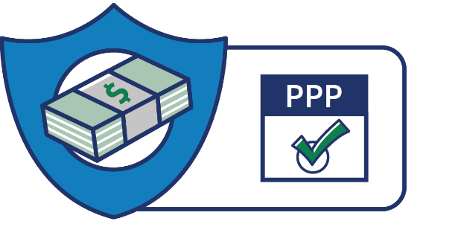](https://www.sba.gov/funding-programs/loans/coronavirus-relief-options/paycheck-protection-program)[](https://www.sba.gov/)